ASSIGNMENT - 5

**CSP - 554 BIG DATA TECHNOLOGIES**

Exercise 1) 2 points

Create new versions of the foodratings and foodplaces files by using TestDataGen (as described in assignment #4) and copy them to HDFS

Magic Number: 31949

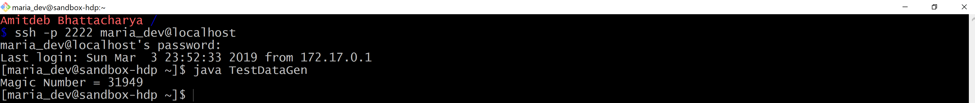

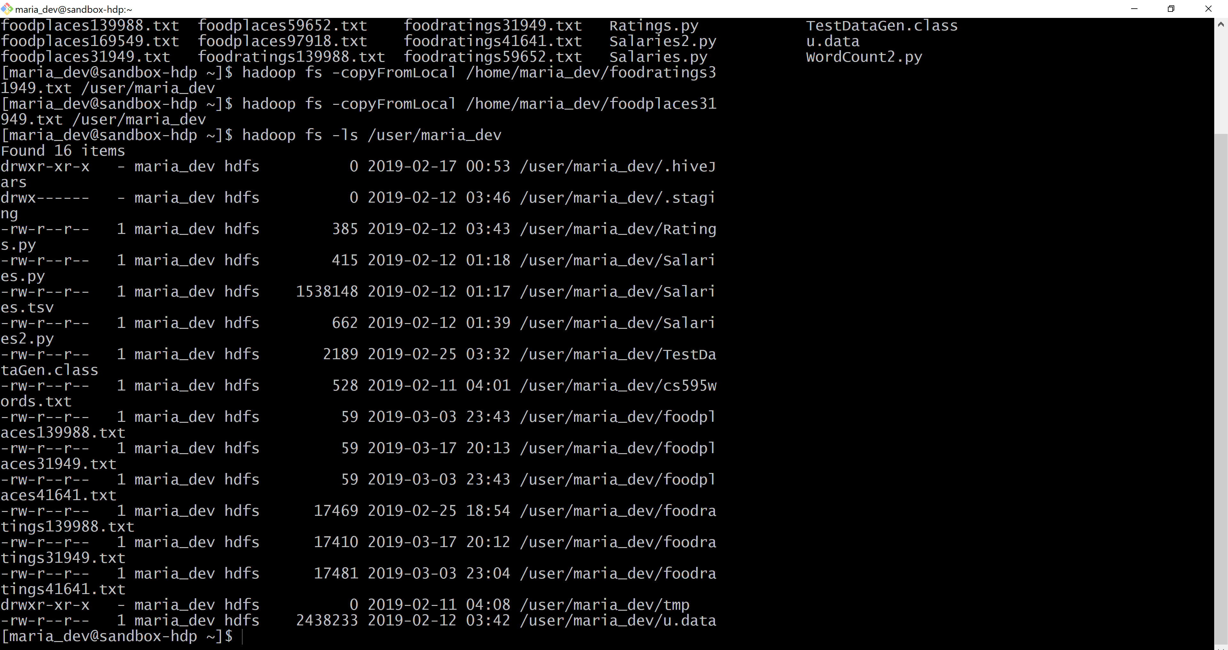

Write and execute a sequence of pig latin statements that loads the foodratings file as a relation. Call the relation ‘food_ratings’. The load command should associate a schema with this relation where the first attribute is referred to as ‘name’ and is of type chararray, the next attributes are referred to as ‘f1’ through ‘f4’ and are of type int, and the last field is referred to a ‘placeid’ and is also of type int.

Execute the describe command on this relation.

Provide the magic number, the load command you wrote and the output of the describe command as the result of this exercise.

**Commands:**

**1) food_ratings = LOAD '/user/maria_dev/ foodratings31949.txt' USING PigStorage(',') AS (name:chararray, f1:int, f2:int, f3:int, f4:int, placeid:int);**

**2) DESCRIBE food_ratings;**

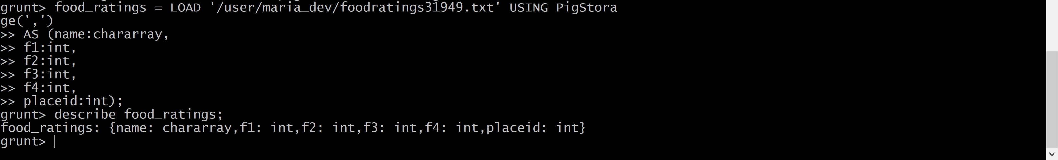

Exercise 2) 2 points

Now create another relation with two fields of the initial (food_ratings) relation: ‘name’ and ‘f4’. Call this relation ‘food_ratings_subset’.

Store this last relation back to HDFS.

Also write 6 records of this relation out to the console.

Submit the pig latin statements you used and the six records printed out to the console as the result of this exercise.

**Commands:**

**1) food_ratings_subset = FOREACH food_ratings GENERATE name, f4;**

**2) STORE food_ratings_subset INTO '/user/maria_dev/food_ratings_subset' USING PigStorage(',');**

**3) six_food_ratings_subset = LIMIT food_ratings_subset 6;**

**4) DUMP six_food_ratings_subset;**

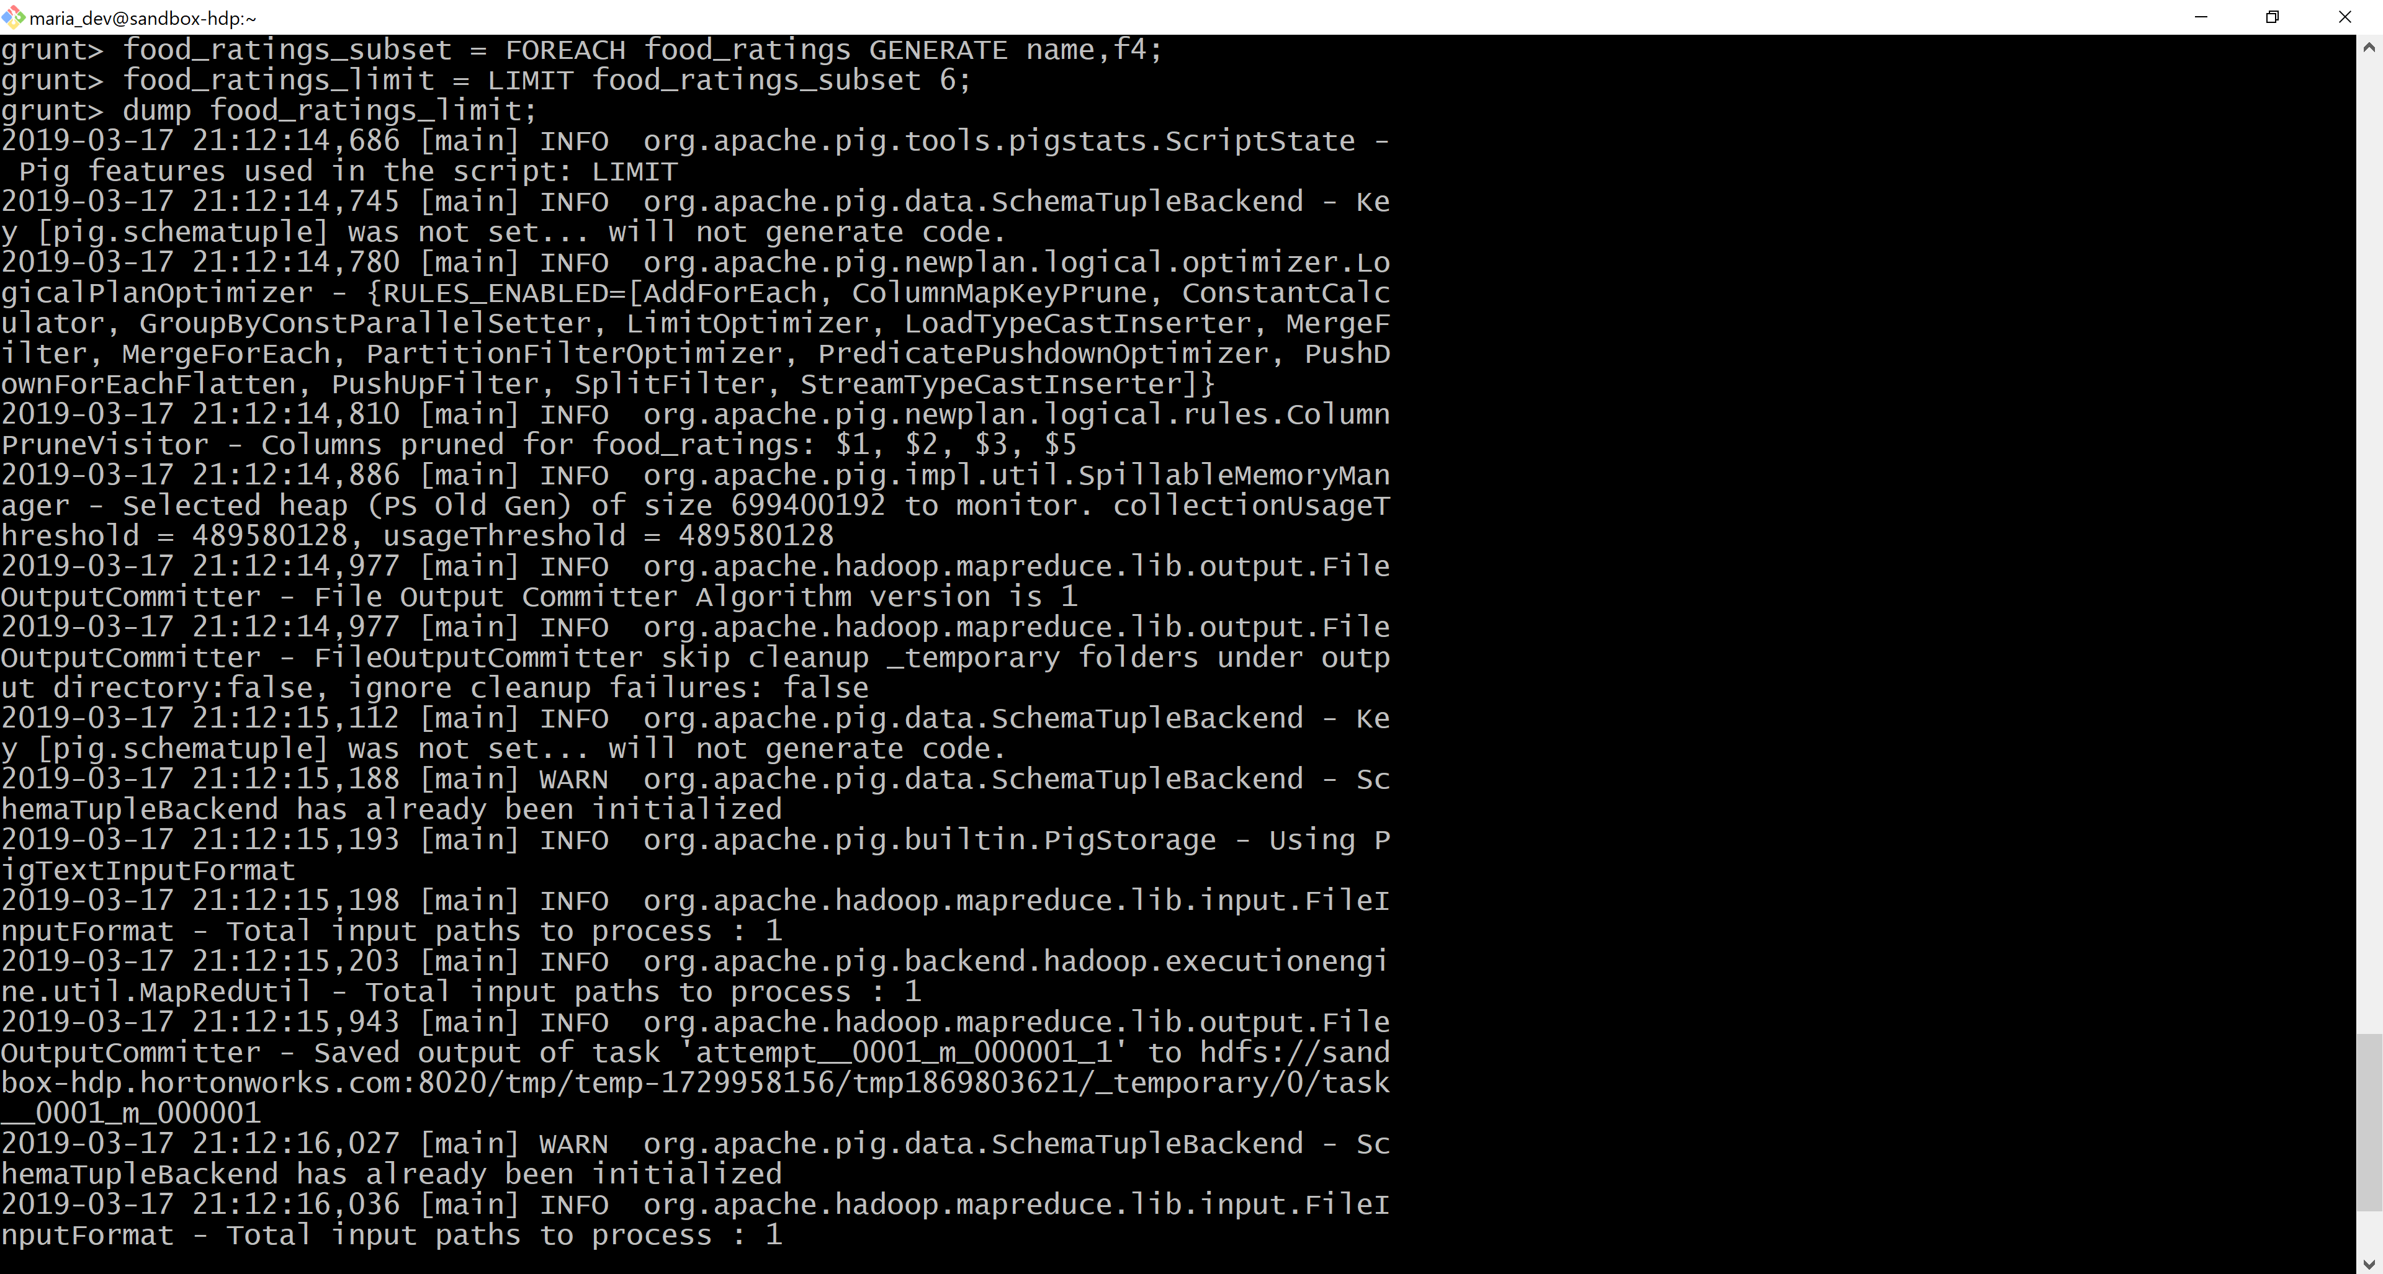

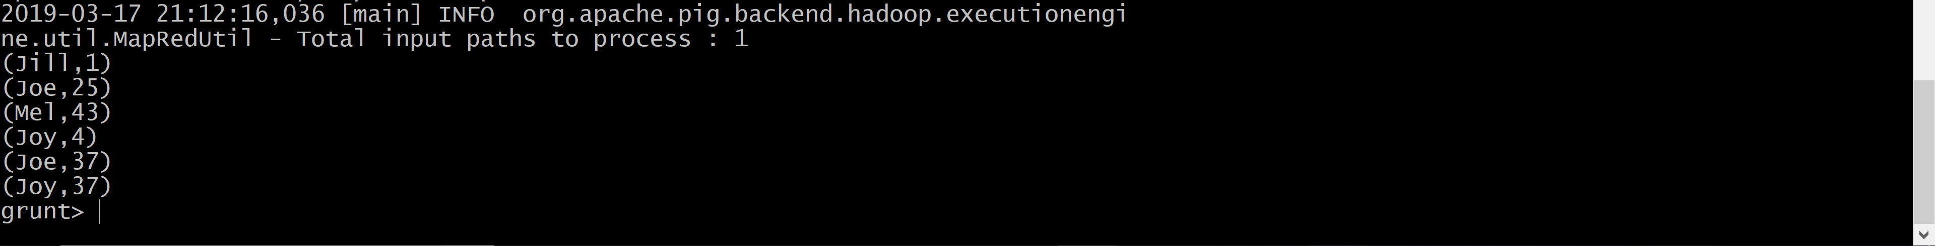

Exercise 3) 2 points

Now create another relation using the initial (food_ratings) relation. Call this relation ‘food_ratings_profile’. The new relation should only have one record. This record should hold the minimum, maximum and average values for the attributes ‘f2’ and ‘f3’. (So this one record will have 6 fileds).

Write the record of this relation out to the console.

Submit the pig latin statements you used and the record printed out to the console as the result of this exercise.

**Commands:**

1. **food_ratings_profile = FOREACH (GROUP food_ratings ALL) GENERATE MIN(food_ratings.f2), MAX(food_ratings.f2), AVG(food_ratings.f2), MIN(food_ratings.f3), MAX(food_ratings.f3),**

**AVG(food_ratings.f3);**

1. **DUMP food_ratings_profile;**

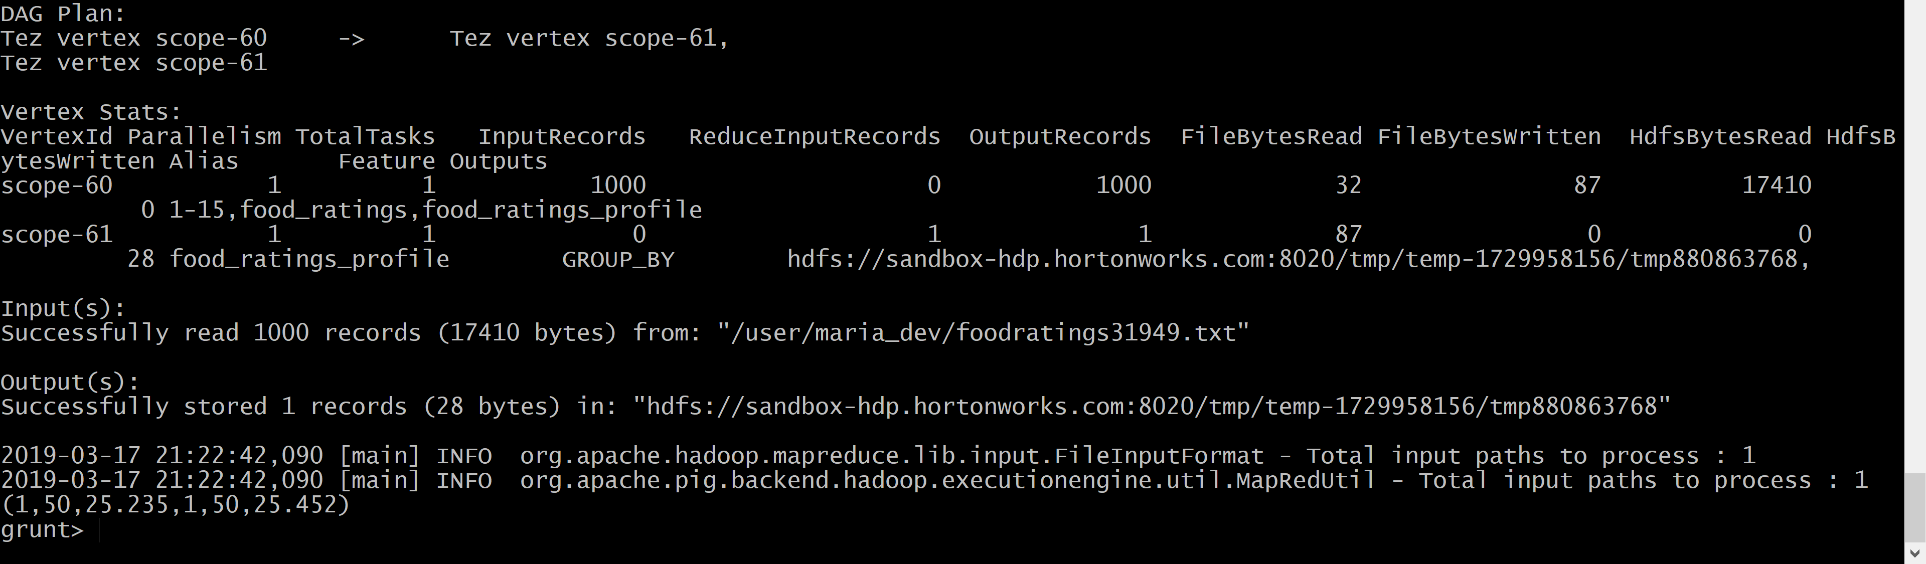

Exercise 4) 2 points

Now create yet another relation from the initial (food_ratings) relation. This new relation should only include tuples (records) where f1 < 20 and f3 > 5. Call this relation ‘food_ratings_filtered’.

Write 6 records of this relation out to the console.

Submit the pig latin statements you used and the six records printed out to the console as the result of this exercise.

**Commands:**

**1) food_ratings_filtered = FILTER food_ratings BY (f1 < 20) AND (f3 > 5);**

**2) Top6_food_ratings_filtered = LIMIT food_ratings_filtered 6;**

**3) DUMP Top6_food_ratings_filtered;**

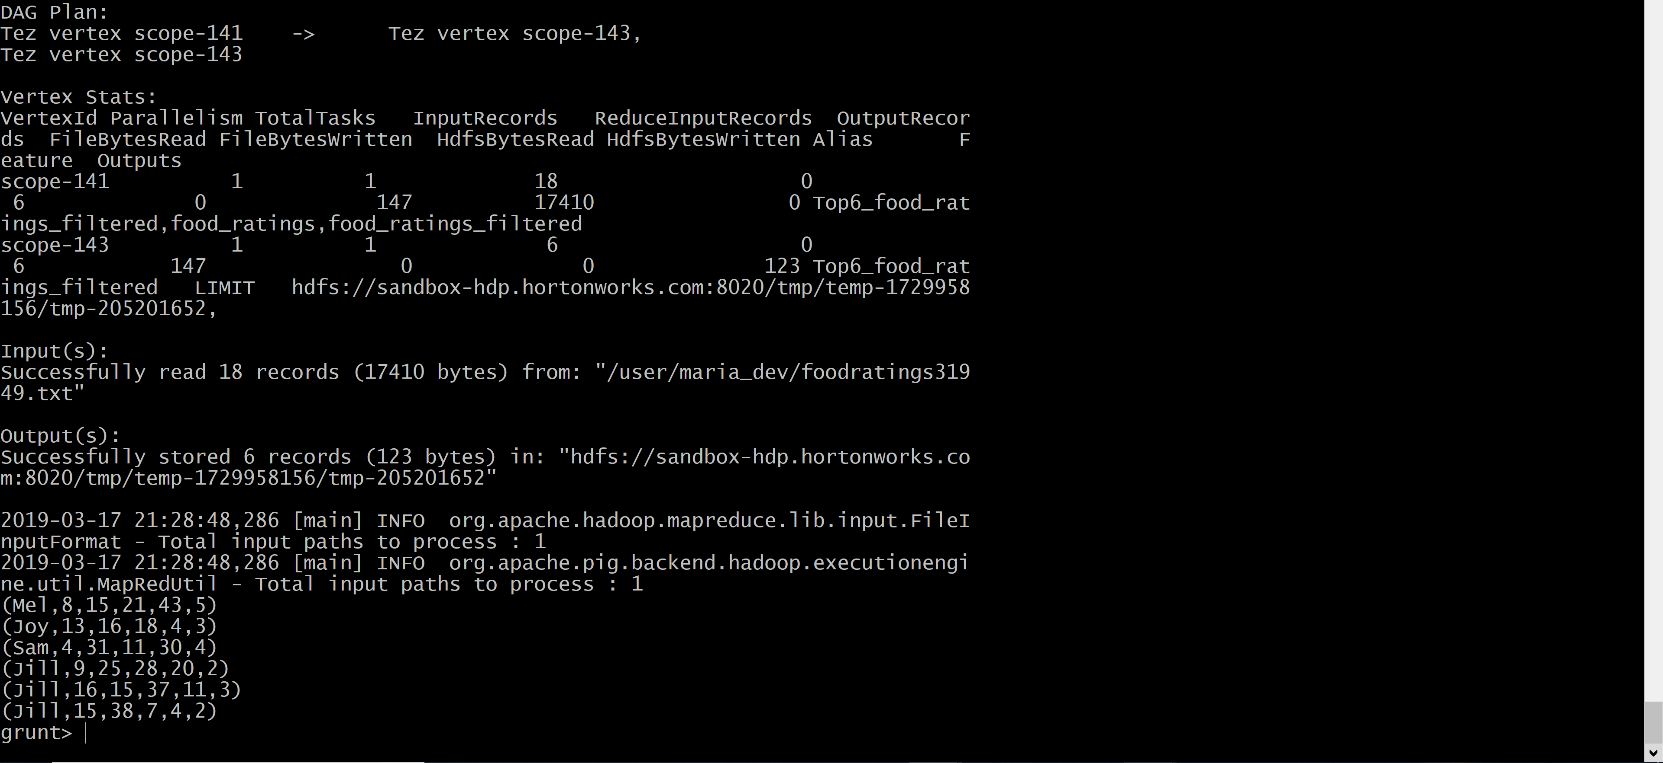

Exercise 5) 2 points

Using the initial (food_ratings) relation, write and execute a sequence of pig latin statements that creates another relation, call it ‘food_ratings_2percent’, holding a random selection of 2% of the records in the initial relation.

Write 10 of the records out to the console.

Submit the pig latin statements and the records printed out to the console.

**Commands:**

**1) food_ratings_2percent = SAMPLE food_ratings 0.02;**

**2) ten_food_ratings_2percent = LIMIT food_ratings_2percent 10;**

**3) DUMP ten_food_ratings_2percent;**

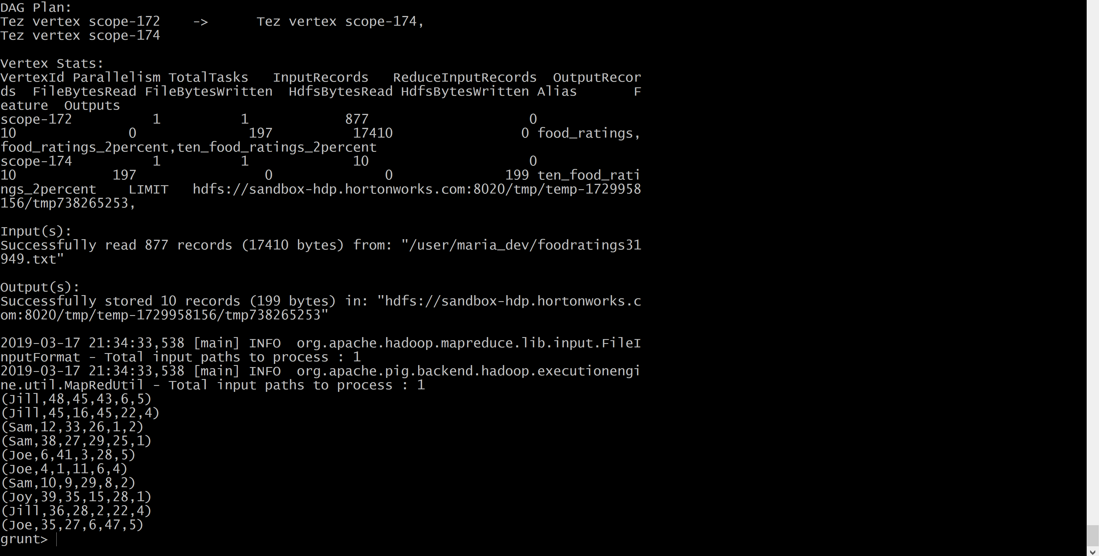

Exercise 6) 2 points

Write and execute a sequence of pig latin statements that loads the foodplaces file as a relation. Call the relation ‘food_places’. The load command should associate a schema with this relation where the first attribute is referred to as ‘placeid’ and is of type int and the second attribute is referred to as ‘placename’ and is of type chararray.

Execute the describe command on this relation.

Now perform a join between the initial place_ratings relation and the food_places relation on the placeid attributes to create a new relation called ‘food_ratings_w_place_names’. This new relation should have all the attributes (columns) of both relations. The new relation will allow us to work with place ratings and place names together.

Write 6 records of this relation out to the console.

Submit the pig latin statements you used and the six records printed out to the console as the result of this exercise.

**Commands:**

**1) food_places = LOAD '/user/maria_dev/foodplaces31949.txt' USING PigStorage(',') AS (placeid:int, placename:chararray);**

**2) DESCRIBE food_places;**



**3) food_ratings_w_place_names = JOIN food_ratings BY placeid, food_places BY placeid;**

**4) six_food_ratings_w_place_names = LIMIT food_ratings_w_place_names 6;**

**5) DUMP six_food_ratings_w_place_names;**

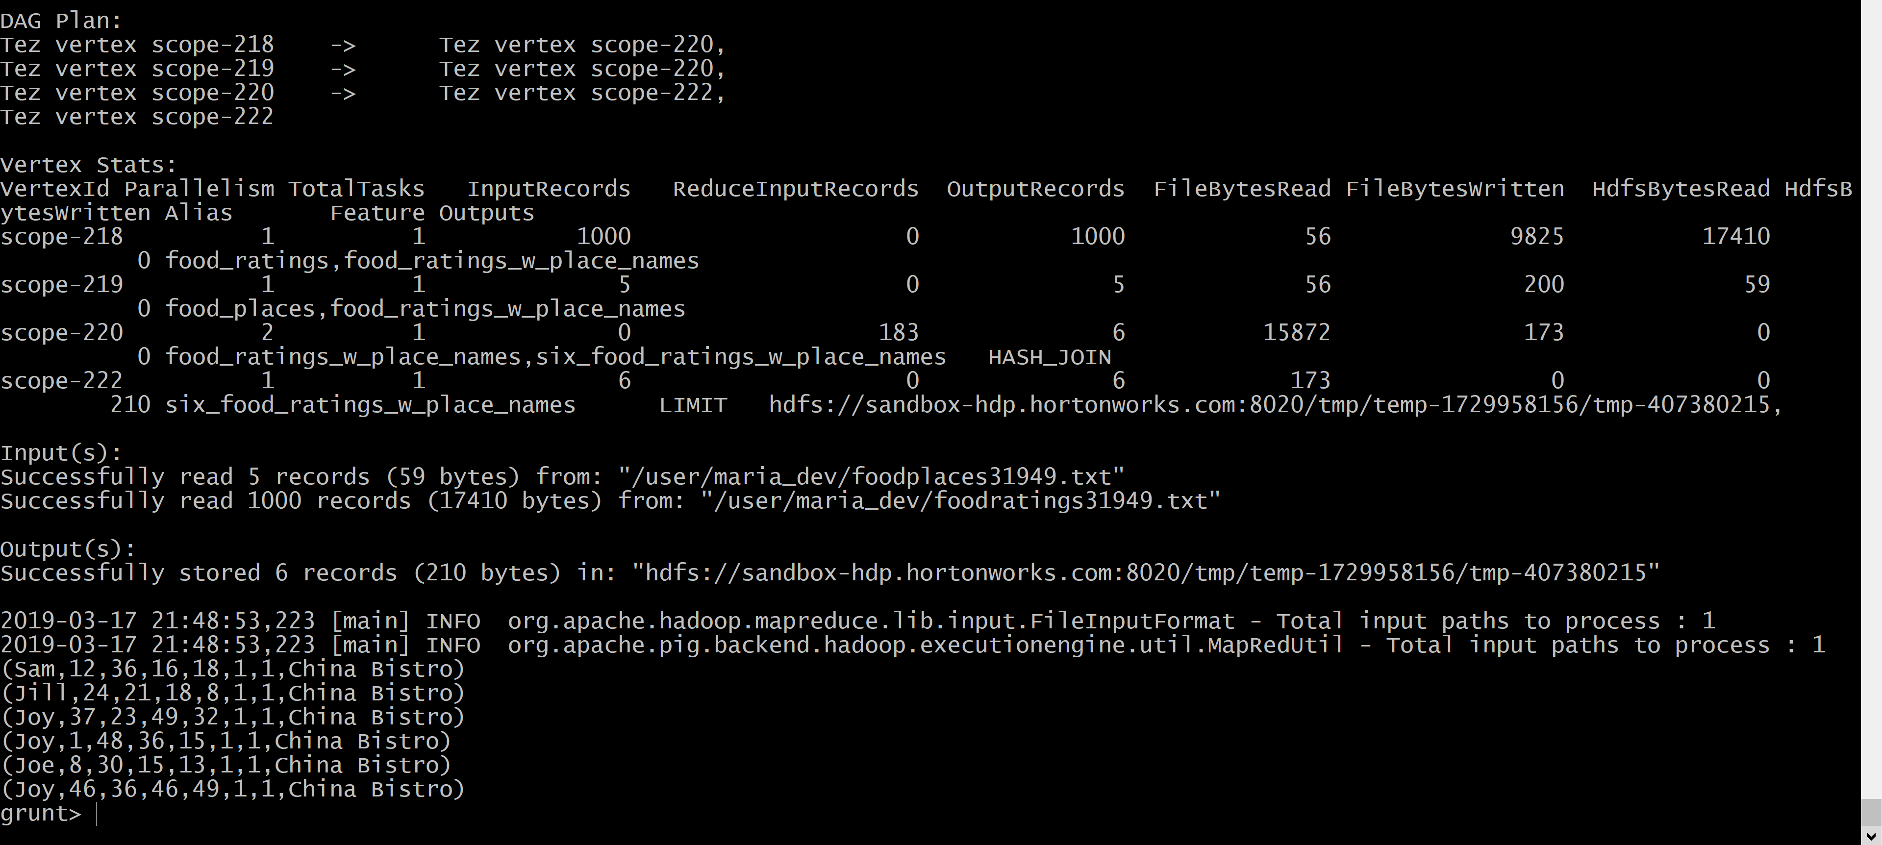

Identify the one correct answer for each the following questions. These questions are similar to the ones you might find on the mid-term covering Pig. Each is worth ½ point.

7) Which keyword is used to select a certain number of rows from a relation when forming a new relation?

Answer: **A. LIMIT**

Choices:

A. LIMIT

B. DISTINCT

C. UNIQUE

D. SAMPLE

8) Which keyword returns only unique rows for a relation when forming a new relation?

Answer: **C. DISTINCT**

Choices:

A. SAMPLE

B. FILTER

C. DISTINCT

D. SPLIT

9) Assume you have an HDFS file with a large number of records similar to the examples below

• Mel, 1, 2, 3

• Jill, 3, 4, 5

Which of the following would NOT be a correct pig schema for such a file?

Answer: **B. (f1: STRING, f2: INT, f3: INT, f4: INT)**

Choices:

A. (f1: CHARARRY, f2: INT, f3: INT, f4: INT)

B. (f1: STRING, f2: INT, f3: INT, f4: INT)

C. (f1, f2, f3, f4)

D. (f1: BYTEARRAY, f2: INT, f3: BYTEARRAY, f4: INT)

10) Which one of the following statements would create a relation (relB) with two columns from a relation (relA) with 4 columns? Assume the pig schema for relA is as follows: (f1: INT, f2, f3, f4: FLOAT) Answer: **B. relB = FOREACH relA GENERATE $0, f3;**

Choices:

A. relB = GROUP relA GENERATE f1, f3;

B. relB = FOREACH relA GENERATE $0, f3;

C. relB = FOREACH relA GENERATE f1, f5;

D. relB = FOREACH relA SELECT f1, f3;

11) Pig Latin is a **data flow** language. Select the best choice to fill in the blank.

Choices:

A. functional

B. data flow

C. procedural

D. declarative

12) Given a relation (relA) with 4 columns and pig schema as follows: (f1: INT, f2, f3, f4: FLOAT) which one statement will create a relation (relB) having records all of whose first field is less than 20

Answer: **A. relB = FILTER relA by $0 < 20**

Choices:

A. relB = FILTER relA by $0 < 20

B. relB = GROUP relA by f1 < 20

C. relB = FILTER relA by $1 < 20

D. relB = FOREACH relA GENERATE f1 < 20